S3 Storage Bucket

Name-Nisarga Kunder

Step1-Bucket-Creation

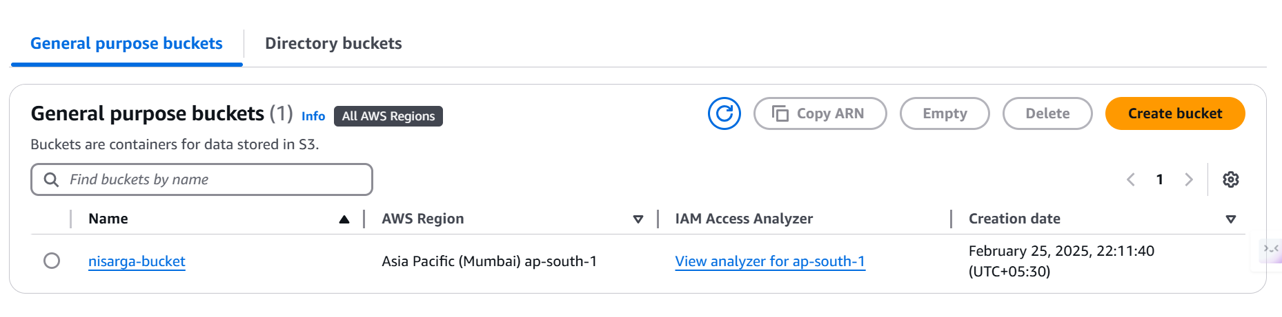

Step2-Uploaded index.html

Step3-Applying versions

Step 4:configuring AWS through CLI

Creating bucket through cli

Created bucket-

Uploaded data through CLI:

Step 5:Spring Boot interaction with S3 bucket

Creating bucket through spring boot and testing on postman

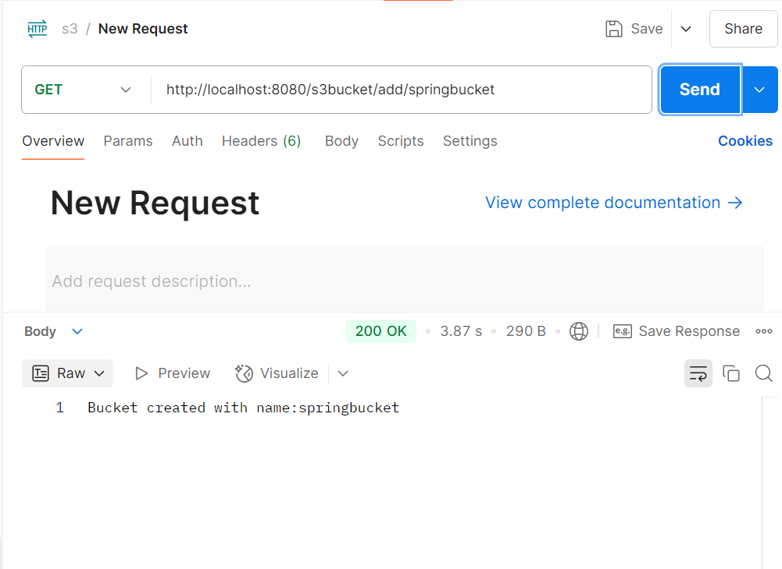

Uploading data to buckets

